

**Preliminary Report**

**Home Energy Management System (HEMS)**

by

Jack Harding

This Report is submitted in partial fulfilment of the requirements of the Honours Degree in Electrical and Electronic Engineering (DT021A) of the Dublin Institute of Technology

5 February 2019

Supervisor: John Dalton

# Introduction

A study from consulting firm McKinsey found that in modern data centres only 6 to 12 percent of the total electrical power used was on computation-the rest being spent on standby. This gross waste of energy along with many modern households having the ability to generate green energy and run relatively independently from the grid, requires the need for a system to manage when and how electrical power comes into the home.

# Objective

The objective of this report is to design and build a prototype that monitors and controls both energy consuming and producing devices. This platform will provide energy management for Prosumers; who both produce and consume energy, it will be based upon a Raspberry Pi microcontroller with the openHAB framework to handle basic home devices as well as energy generation devices such as PV panels and wind turbines.

The monitoring of the devices is to be done with multiple wattmeter’s connected via RF across the environment, they will be measuring the power used by each device, this information will be relayed to a common gateway (Raspberry Pi). This is where much of the analysis will be done, the usage among devices needs to be categorised into ones that can have energy saved and devices that require constant power e.g. fridge, modem. The data received will allow the energy generated by the onsite renewables, to be used intelligently to maximise self-consumption. This can be achieved by using onsite batteries to store the energy generated when the wind blows and sun shines so that when the consumers needs to use the electricity (typically in the evening) its ready to go.

Control over the appliances is to be done to min

# Ethics

### ThingSpeak

One of the options for hosting the information online is ThingSpeak, an IoT platform that allows analysis, visualisation and storage of data collected from sensors, sent via Arduino or Raspberry Pi. This platform allows data logs from sensors to be used in the MATLAB environment, making complex analysis of historical data possible. To start, a channel must first be created, this contains data, location, and state fields. This data can then be graphed to visualise the usage of a certain appliance in this case and adjust, to lower power usage. The first channel created is the Smart Plug, it is connected via Z-Wave and has two fields; state (is device on/off) and Power (how much has been used so far). ThingSpeak offers a MQTT API also.

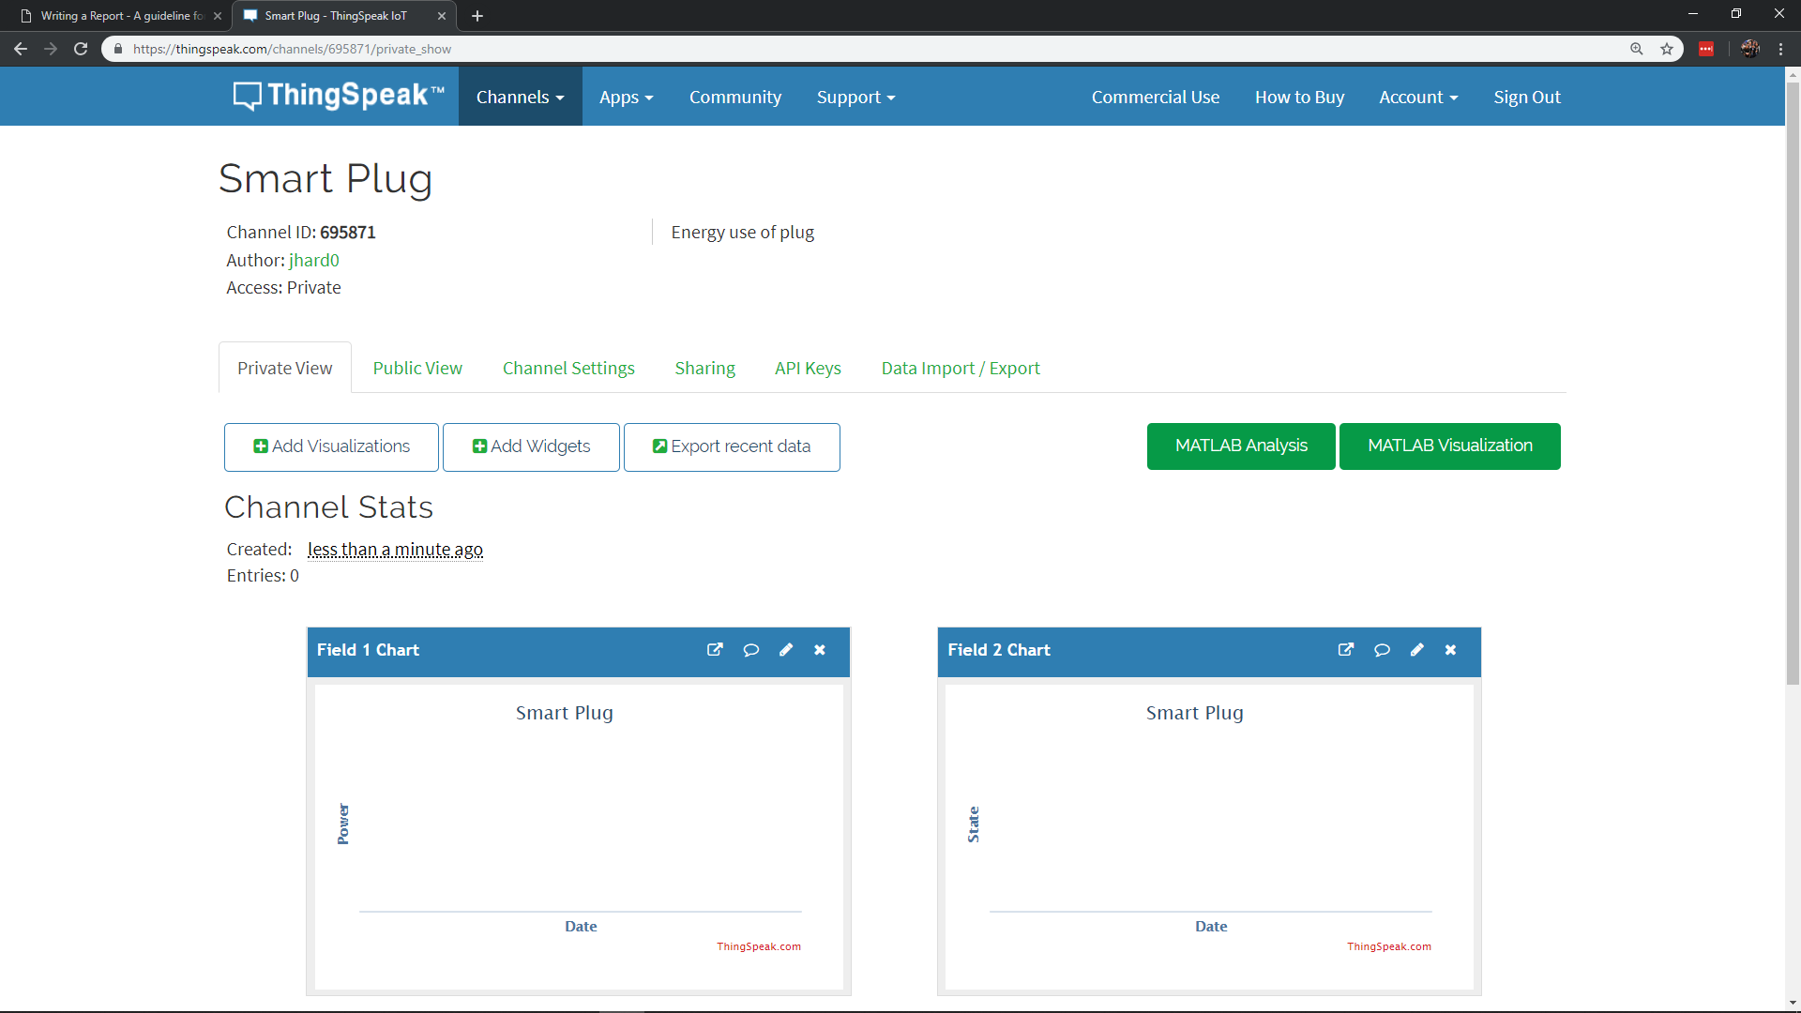

### Influx & Grafana

InfluxDB is an open source time series database used for engineering applications for its high accuracy timing (within nanoseconds) and the mandatory timestamp with every entry into the database. Grafana is also open source and is used for visualising time series data for sensors, weather applications and home automation.

## Gateway

The gateway is used as a central hub and a point where the devices such as sensors connect to the cloud, this gateway usually has a way of organising the data before uploading, this usually includes some form of encryption to ensure the security of that HAN. The choice of gateway is very important when it comes to usability, security and reliability.

### HomeSeer

### Raspberry Pi

## Framework

### OpenHAB

### Home Assistant

# References

[1] D. Das, "What is Locality of Reference in Cache Memory with Diagram", *CSETutor*, 2018. [Online]. Available: https://www.csetutor.com/locality-of-reference-in-cache-memory/. [Accessed: 18- Oct- 2018].